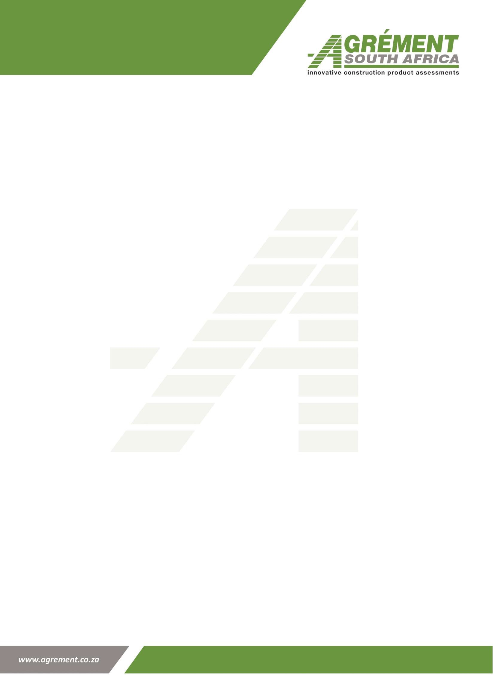
Annexure B

ANNEXURE B: Confirmation of Independence

Agrément South Africa Infotech Building
1090 Arcadia Street Pretoria
Hatfield Date:

To Whom it May Concern,

Letter of confirmation of independence from Agrément South Africa

[Insert Firm name] hereby confirms that independence and ethical requirements by all team members proposed for this assignment, are communicated during the planning, field work and finalisation phases of the audit and are monitored on a continuous basis.

I hereby confirm that our firm is independent with regard to Agrément South Africa and its related parties. I further confirm that all proposed members of the above engagement are in compliance with independence requirements as set out in the IFAC Code of Ethics and the Quality Control Policies and Procedures of the firm and no matters have occurred during the duration of the financial years (2021/22 - 2025/26) and the pre-planning phase of the audit which may impair the firm’s independence.
I hereby confirm that [insert Firms name] currently does not do, nor have we done any work for Agrément South Africa which may result in a direct conflict of interest.

I hereby confirm that there is no conflict of interest between Agrément South Africa and any of the staff members involved in the audit. The capabilities and competence of the staff assigned to the audit was also assessed and found to be sufficient.

I further confirm that none of the directors of our firm sit on any audit or advisory committees of Agrément South Africa.

Annexure B

hereby confirm that [Insert Firms name] has not been subject to any issues regarding ethical misconduct and the firm is currently not involved in any scandals which may impact our reputation. Yours sincerely,

Signature

(Name of audit Partner)

